December, 2021
This web page is now separated into 4 segments:
- Hope and Humor. This section features selections from various sources and individuals who display and exhibit an active sense of humor (at least in this writer’s opinion). This month’s selection comes from authors Jennifer Aaker and Naomi Bagdonas who have written a delightful book entitled Humor, Seriously: Why Humor is a Secret Weapon in Business and in Life. My hope is that this month and continuing into the future your relationships with your family, your friends, and your interactions at work will be filled with humor and hope and that you will establish or re-establish connections with the significant people in your life.
- Featured “Punster” of the Month – This section will continue to include a few puns from various authors and writers. Each month, a different punster will be featured in this section. This month’s selections come from Puns for Groan People by John G. Moore.
- “Hope’s” Curious and Captivating Cartoon Characters - Hope and Harry and Simon and Specs – These are Cartoon characters I have enjoyed creating in the past and resurrected for this website. As a frustrated artist during my undergraduate college years, I switched to trying my hand at cartooning and created a couple of characters. This month, Simon and Specs friend, Sally, will be joining Specs as they determine whether Santa is an independent or dependent “Clause”. Hope, the cat, and Harry, the dog will again be featured as they continue to address some of the common idioms, terms, proverbs, cliches, expressions, sayings, and abbreviations in the English language … interjecting a few puns along the way.
- Hope Matters! Selected quotes referencing Hope and Resilience - This section will continue to feature selected quotes from various sources referencing Hope and Resilience throughout the ages.
- HOPE AND HUMOR
Humor, Seriously –The use of humor can exist in all our relationships…not just those in our family encounters and social situations, but also at work and in our business lives … And, as a matter of fact,… throughout our lives. From the opening Prelude entitled “Humor Makes Us Human”, to the final conversation with Michael Lewis in the Afterward, the authors of Humor, Seriously: Why Humor is a Secret Weapon in Business and in Life. (2021). Penguin Random House LLC. New York, NY., articulate the importance of humor in our lives. Based on their coursework and lectures at the Graduate School of Business at Stanford University, Dr. Jennifer Aaker and Naomi Bagdonas have provided us with a textbook of tools, examples, and illustrations to guide us in the use of humor at work and throughout our lives.
They have also provided insights into navigating the “Gray Areas of Humor” which reveal the spectrum of what individuals view as funny. Not everyone finds an attempted humorous comment to be equally funny or even appropriate. As the authors explain: “In our current era of heightened sensitivities, political polarization, and cancel culture, using humor at work can feel riskier than ever.” (pg. 196).
I also found it interesting that the authors cite a consulting example which identified certain phrases or jargon we often use to preface or support our communication…phrases like: “Circle Back, Move the Needle, Touch Base, Push the Envelope, Run it Up the Flagpole, Ping Me, Peel the Onion, and Sync Up” as well as individual words such as “leverage, incentivize, bleeding edge, robust, and synergize.” (pgs. 103-104). These were words that I often heard in my business dealings and seemingly had little meaning to the task or project at hand…nor did they contribute to the progress of either.
Humor has also been found to increase 1) our perceptions of power to influence our behavior and decision making, 2) Our bonds / relationships with others, 3) Our creativity, and (most importantly from our perspective on hope for the future) … 4) Our resilience. (pgs. 43-44).
Among the many examples the authors cite in support of humor in the workplace and business dealings is a case involving a dispute over the slogan “Just Plane Smart” between Stevens Aviation which originally coined the phrase and Southwest Airlines which started unknowingly using the phrase afterward. Instead of attempting to resolve the dispute through litigation, Kurt Herwald CEO of Stevens Aviation challenged Southwest CEO Herb Kellerher to an arm wresting match. The match was held in a Dallas stadium in front of 45 hundred cheering spectators and garnered significant positive results for both airlines. Herwald won the arm wrestling match, but offered to share the slogan with Southwest Airlines in a show of respect and good sportsmanship resulting in positive publicity for both Airlines.
“Humor can be power-enhancing for us and intoxicating to others. It fosters meaningful connections, unlocks creativity, makes tense situations less stressful, and helps us survive and thrive through life’s ups and downs.”
Aaker, Jennifer and Naomi Bagdonas. (2021). Humor, Seriously: Why Humor is a Secret Weapon in Business and in Life. Penguin Random House, New York, NY. Pg. 65.
I would strongly recommend picking up a copy of this book at your local library or from an on-line or neighborhood bookstore.
2) FEATURED “PUNSTER” OF THE MONTH – John G. Moore
Author of Puns for Groan People. (2021). Independently Published.
I just came across this delightful compilation from John Moore recently and I purchased the book. John has apparently been including a weekly pun on his Facebook page since 2010 and finally decided to include many of them in his book. The book is dedicated to his bride, Terry, who thinks he belongs in a “punitentiary.” Here is a sample of his “punmanship”:
“Our waterbed was bouncy. Then I remembered we used Spring water.” Page 27.
“Santa has been here. I can feel his presents.” Page 25.
“The minute it warmed up, our Snowman had a meltdown.” Page 11.
And some Timely puns…
“Ate a clock for breakfast. It was time consuming.” Page 18.
“Named my new pup ‘Rolex’. He’s a watchdog.” Page 12
Many puns stand the test of time, but there are always new words that appear in the English language…especially as they relate to technology advances. Twenty or Thirty years ago, most of us would probably not have grasped the meaning of the following puns:
“Named my new band ‘999 Megabytes’. We don’t have a gig yet.” Page 19.
“Bought my turtle a shell phone.” Page 58.
John G. Moore is definitely a punster to check out and follow in the future.
3) “HOPE’S” CURIOUS AND CAPTIVATING CARTOON CHARACTERS
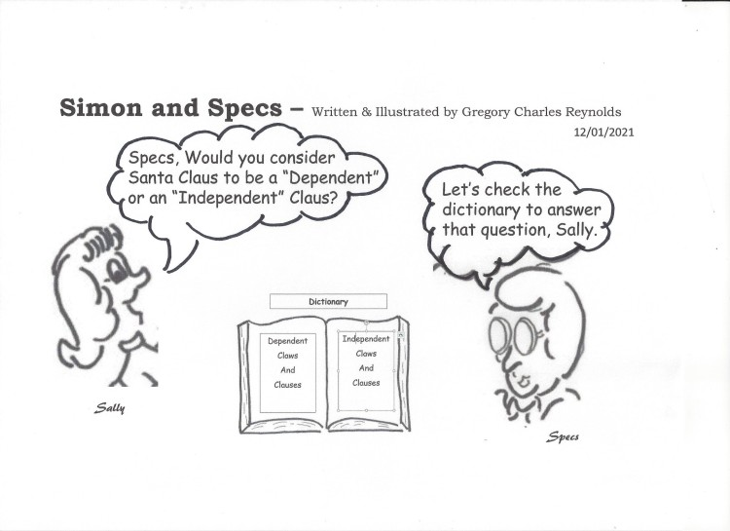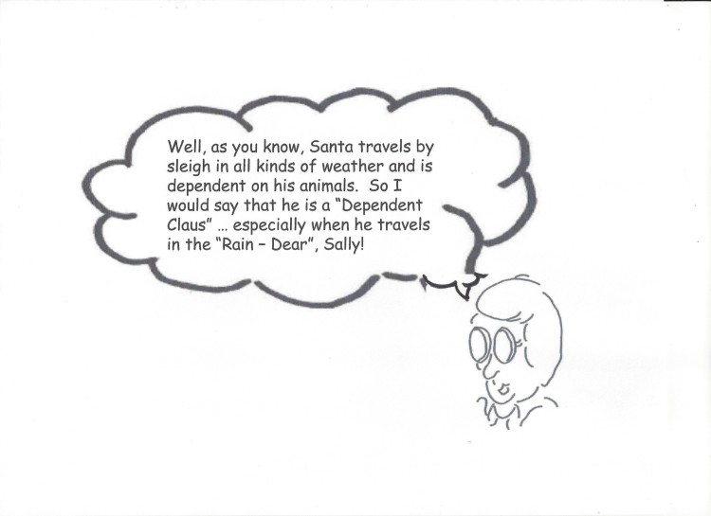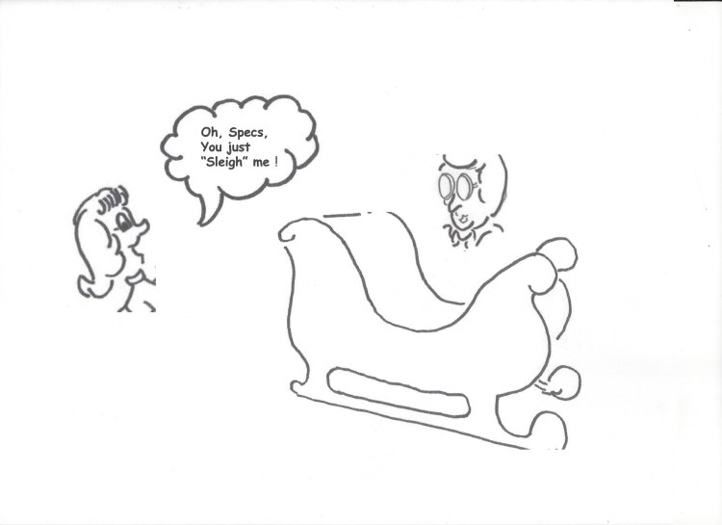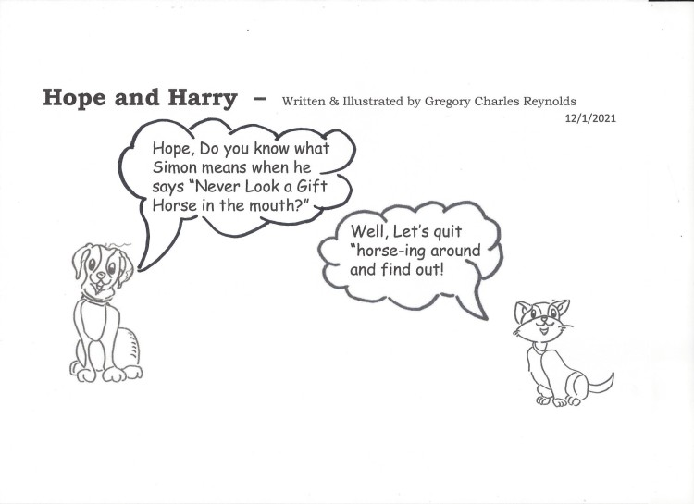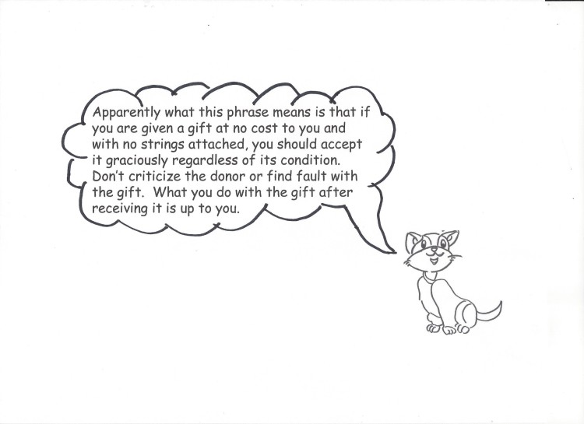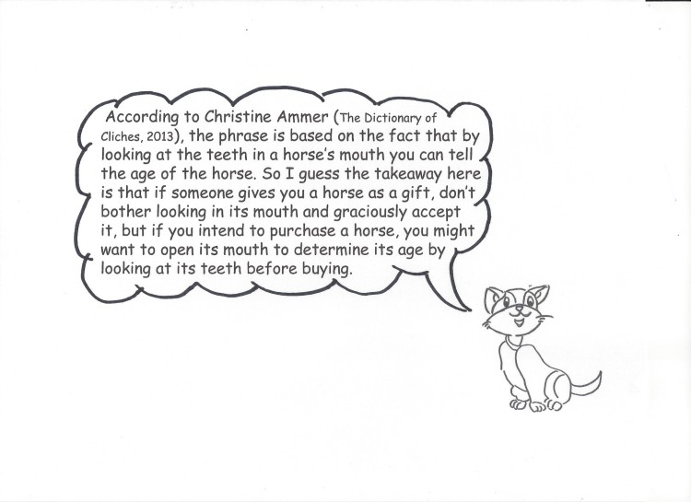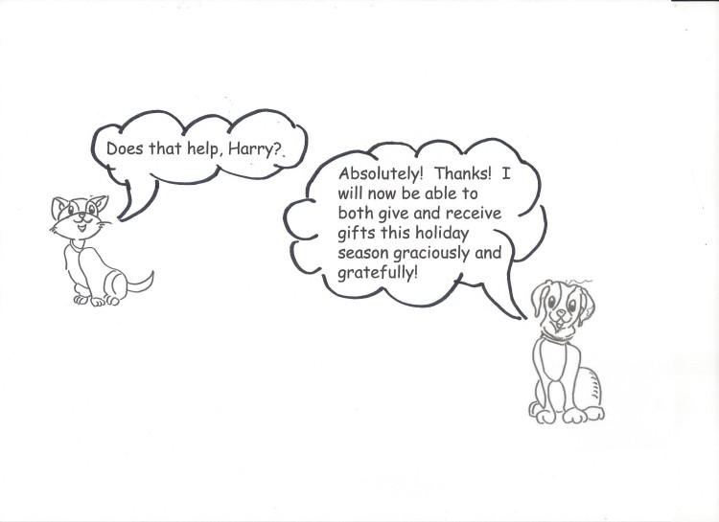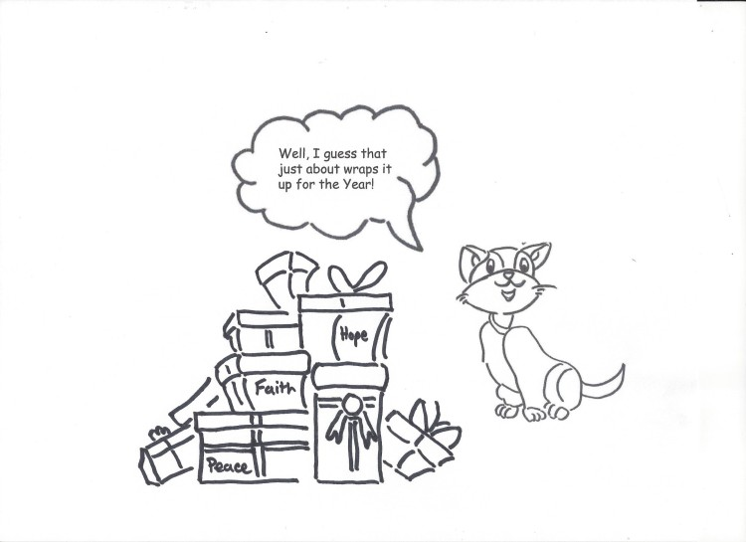
4) HOPE MATTERS! SELECTED QUOTES REFERENCING HOPE AND RESILIENCE
“Wherever you are tonight, you can make it. Hold your head high, stick your chest out. You can make it. It gets dark sometimes, but the morning comes. Don't you surrender. Suffering breeds character, character breeds faith. In the end faith will not disappoint. You must not surrender. You may or may not get there but just know that you're qualified. And you hold on, and hold out. We must never surrender. America will get better and better.”
Reverend Jesse Jackson, "1988 Address to the Democratic National Convention" (from Wikiquotes)
“Going through trials doesn’t mean I am outside of God’s will, but rather that He is with me, guiding me through them.”
Aline Mello – The Safety of God’s Will. March 29, 2021. http://www.intouch.org/read/features/the-safety-of-
“ I would say, we can't allow ourselves to be frightened into not living our lives, and I think that we have to keep going and we have to keep going with the faith that thing will get better … And things will get better when we make them better.”\
Interview on Entertainment Tonight, as quoted in "Oprah Winfrey Offers Words of Wisdom in Wake of Deadly Las Vegas Shooting", KTVB (2 October 2017) Oprah Winfrey – Wiki quotes
Reflections on Peace
“When the power of love overcomes the love of power the world will know peace.”
Jimi Hendrix. https://www.brainyquote.com/quotes/jimi_hendrix_195397
“The most valuable possession you can own is an open heart. The most powerful weapon you can be is an instrument of peace.”
Carlos Santana
“An eye for an eye only ends up making the whole world blind.”
Mahatma Gandhi
“Peace is not the absence of conflict, it is the ability to handle conflict by peaceful means.”
Ronald Reagon
Lord, make me an instrument of thy peace. Where there is hatred, let me sow love.
Francis of Assisi
“Glory to God in the highest, and on earth peace, good will toward men.”
LUKE 2:14 KJV "Glory to God in the highest, and on earth peace, good will toward men." (kingjamesbibleonline.org)
“Peace I leave with you, my peace I give unto you: not as the world giveth, give I unto you. Let not your heart be troubled, neither let it be afraid.”
JOHN 14:27 KJV "Peace I leave with you, my peace I give unto you: not as the world giveth, give I unto you. Let not your..." (kingjamesbibleonline.org)
Enjoy this Holiday Season!
November, 2021
This web page is now separated into 4 segments:
- Hope and Humor. This section features selections from various sources and individuals who display and exhibit an active sense of humor (at least in this writer’s opinion). This month’s selection comes from Dr. Will Miller, a former comedian turned psychologist. Dr. Miller has co-authored a book with the intriguing title “Refrigerator Rights.”
- Featured “Punster” of the Month – This section will continue to include a few puns from various authors and writers. Each month, a different punster will be featured in this section. This month’s selections come from Bennett Cerf– author of Bennett Cerf’s Treasury of Atrocious Puns.
- “Hope’s” Curious and Captivating Cartoon Characters - Hope and Harry and Simon and Specs – These are Cartoon characters I have enjoyed creating in the past and resurrected for this website. As a frustrated artist during my undergraduate college years, I switched to trying my hand at cartooning and created a couple of characters. This month, Hope, the cat, and Harry, the dog will again be joining Simon and Specs as they address some of the common idioms, terms, proverbs, cliches, expressions, sayings, and abbreviations in the English language … interjecting a few puns along the way.
- Hope Matters! Selected quotes referencing Hope and ResilienceThis section will continue to feature selected quotes from various sources referencing Hope and Resilience throughout the ages.
- HOPE AND HUMOR
Refrigerator Rights –
During this Thanksgiving season when our thoughts often turn to the abundance many of us have access to in our lives, my thoughts often turn to food and relationships with family and friends.
Several years ago, a friend introduced me to a former comedian who published a book entitled “Refrigerator Rights: Creating Connections and Restoring Relationships. The primary author, Dr. Will Miller and his co-author, Dr. Glenn Sparks, have since updated the original book with new material. Although the book does not contain many humorous anecdotes, I find the phrase and concept of “Refrigerator Rights” something that tickles my funny bone and is highly appropriate as we approach this season of thankfulness.
Just exactly what are Refrigerator Rights? As the authors explain it,
If a stranger was invited into your house and kitchen for a first time visit, you would be appalled if he got up, walked over to your refrigerator and started taking out the makings for a sandwich without even asking you first. However, if a family member were to do the same thing without asking, you would generally allow it and certainly not be very upset. The same thing holds true to a certain extent with very close friends or acquaintances. They might probably ask the first time if it were OK to reach in for a bottle of water or soda. And you would probably respond: “Sure, go right ahead. Anytime.” You have effectively granted them “Refrigerator Rights”.
Strangers don’t have refrigerator rights, but family members and close friends do. In essence, they have been granted “Refrigerator Rights” as a result of their close relationship to you.
The main premise of the book is that in today’s media saturated world, we have lost many of the close relationships that we once experienced and the number of “Refrigerator Rights” we now grant to others has been significantly reduced.
The authors go on to assert that we now are substituting the “Media” for people and state:
“It’s our belief that modern life has been profoundly affected by the loss of refrigerator-rights relationships. We’ve lost them through three major social changes: increased mobility, heavy social emphasis on individualism, and emotionally numbing distractions.” . . .
“We used to hope that the easy availability of information would make us more efficient, more informed, better connected. But in fact, we’re now starting to see that our gadgets only make us more self-absorbed.”
Miller, Dr. Will; Sparks, Dr. Glenn. Refrigerator Rights: Creating Connections and Restoring Relationships . White River Press. Kindle Edition.
My hope is that this month and continuing into the future your relationships will be filled with humor and hope and that you will establish or re-establish “Refrigerator Rights” with the significant people in your life.
2) FEATURED “PUNSTER” OF THE MONTH – Bennett Cerf
Author of Bennett Cerf’s Treasury of Atrocious Puns.(1968). Harper Collins. New York, NY.
Puns stand the test of time! This month’s punster, Bennett Cerf, was born in 1898 in Manhattan New York. He was a prolific author, cofounder of Random House Publishing in 1927 and was a weekly panelist on the CBS show “What’s My line?” from 1951 to 1967. He was also known as “Bennett Snerf” in a Sesame Street puppet parody of “What’s My Line?”. He is featured this month especially to highlight the fact that puns have been popular for decades!
Some of Cerf’ noteworthy puns include the following:
“There’s a kangaroo in the San Diego Zoo who lacks zip He’s frequently discovered out of ‘bounds’.”
Cerf, Bennet. (1968). Bennett Cerf’s Treasury of Atrocious Puns. Harper and Row Publishers. New York. pg. 19.
“A Duluth fortune-teller gazed into his crystal ball and told his young lady client that something very amusing was about to happen to her. Then he (the fortune-teller) burst into uproarious laugher. The young lady rose and smacked his face. ‘Why did you do that?’ asked the astounded clairvoyant. ‘My mother,’ she said firmly, ‘always told me to strike a happy medium!’”
Cerf, Bennet. (1968). Bennett Cerf’s Treasury of Atrocious Puns. Harper and Row Publishers. New York. pg. 110.
“The Volkswagen belonging to a Reed undergraduate in Portland, Oregon, broke down once too often. So he consigned it to the Old Volks Home.
Cerf, Bennet. (1968). Bennett Cerf’s Treasury of Atrocious Puns. Harper and Row Publishers. New York. pg. 110.
Puns can definitely be “dated” as technology advances…. The following entry regarding a telephone wire (which we may now rarely use … except as a conduit for the internet) illustrates this fact:
“A wise old crow perched himself firmly on a telephone wire. He wanted to make a long-distance caw.”
Cerf, Bennet. (1968). Bennett Cerf’s Treasury of Atrocious Puns. Harper and Row Publishers. New York. pg. 23.
“An ingenious postman cut a big hole in the bottom of his pouch, declaring proudly, ‘The mail must go through.”
Cerf, Bennet. (1968). Bennett Cerf’s Treasury of Atrocious Puns. Harper and Row Publishers. New York. pg. 94.
But some things are timeless across the years …
“An alert San Antonio restauranteur has this suggestion printed atop the dessert list on his menus: ‘Remember the alamode.’ ”
Cerf, Bennet. (1968). Bennett Cerf’s Treasury of Atrocious Puns. Harper and Row Publishers. New York. pg. 106.
And a few riddles:
“Q. Do we get fur from a skunk?
- Yes, as fur away as possible.”
Cerf, Bennet. (1968). Bennett Cerf’s Treasury of Atrocious Puns. Harper and Row Publishers. New York. pg. 100.
“Q. What’s a small dog suffering from the chills?
- pupsickle.”
Cerf, Bennet. (1968). Bennett Cerf’s Treasury of Atrocious Puns. Harper and Row Publishers. New York. pg. 99.
3) “HOPE’S” CURIOUS AND CAPTIVATING CARTOON CHARACTERS
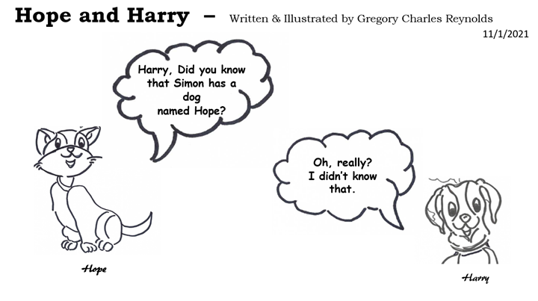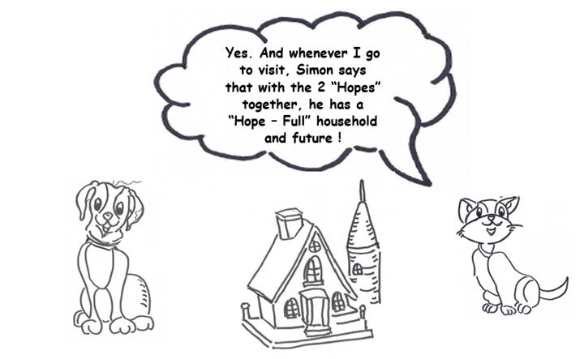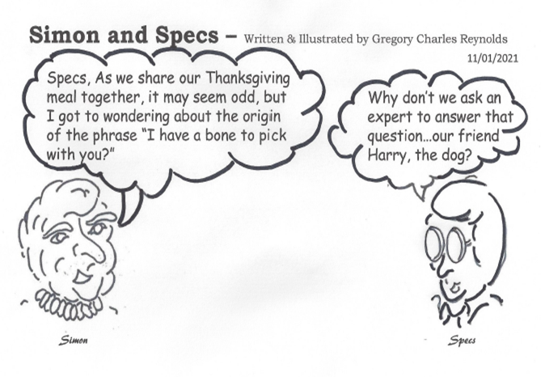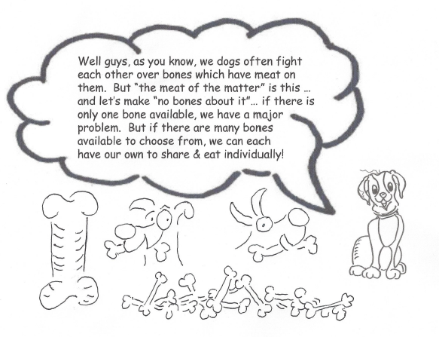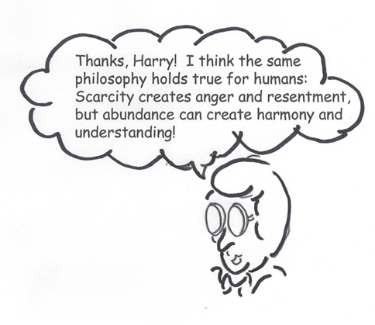
4) HOPE MATTERS! SELECTED QUOTES REFERENCING HOPE AND RESILIENCE
- “You can’t always choose the path that you walk in life, but you can choose the manner in which you walk it.”
O’Leary, John. (2016). On Fire: The 7 Choices to Ignite a Radically Inspired Life. North Star Way / Simon & Schuster, New York, NY.
- “The stories that stick with us are hopeful stories, not ones of despair. They remind us that there are others before us who suffered and were transformed. The world’s great religious traditions offer exemplars of people who suffered---Moses, Jesus, Buddha, Mohammed. Their stories provide guidance and hope. They teach us that as bad as it feels now, suffering does not have to be the final word in life.”
Pargament, Kenneth. “The Many Methods of Religious Coping: Development and Initial Validation of the RCOPE,” Journal of Clinical Psychology 56, no. 4 (April, 2000).
- “Hope can arrive only when you recognize that there are real options and that you have genuine choices. Hope can flourish only when you believe that what you do can make a difference, that your actions can bring a future different from the present. To have hope, then, is to acquire a belief in your ability to have some control over your circumstances. You are no longer entirely at the mercy of forces outside yourself.”
Groopman, Jerome, MD. (2005). “The Anatomy of Hope: How People Prevail in the Face of Illness." Random House Trade Paperbacks. New York, NY. Page 26.
On Gratitude and Thanksgiving
- “Gratitude turns what we have into enough and more. It turns denial into acceptance, chaos into order, confusion into clarity…it makes sense of our past, brings peace for today, and creates a vison for tomorrow.”
Melody Beattie as quoted in Allen, Scott (2021. Empower Your Gratitude. Scott Allen Publishing. page 36.
- “Be thankful for what you have; you’ll end up having more. If you concentrate on what you don’t have, you will never, ever have enough.”
Oprah Winfrey
- “We make a living by what we get. We make a life by what we give.”
Winston Churchill https://en.wikiquote.org/w/index.php?title=Hope&oldid=2998066
- “O Lord, that lends me life, Lend me a heart replete with thankfulness!
William Shakespeare, Henry VI, Part II (c. 1590-91), Act I, scene 1.
- “Piglet noticed that even though he had a Very Small Heart, it could hold a rather large amount of Gratitude.”
Milne, Alex Alexander (1926). Winnie the Pooh.
- “Gratitude is not an attitude that comes to most of us easily. It is a learned skill. It is the ability to see and say thank you the many gifts in our life as they are unfolding…There is always some small thing for which we can be grateful—and often many larger things as well.”
Cameron, Julia. (2009). FAITH and WILL: Weathering the Storms in Our Spiritual Lives. Jeremy P. Tarcher / Penguin Group, New York, NY. Page 81.
- "Gratitude and attitude are not challenges; they are choices."
Robert Braathe (As quoted in Wikiquotes - Gratitude - Wikiquote
- “Gratitude is the golden frame through which we can see the meaning of life.”
Brandon Burchard. (2021). Sunday Growth Notes. @brendonburchard.
Happy Thanksgiving!
Punchlines - October 2021
This web page is now separated into 4 segments:
- Hope and Humor. This new section will feature selections from various sources and individuals who display and exhibit an active sense of humor (at least in this writer’s opinion). This month’s selection comes from the website GENLISH.com (So you think English is easy? - Genlish), and takes a look at the use and pronunciation of many of our English words.
- Featured “Punster” of the Month – This section will continue to include a few puns from various authors and writers. Each month, a different punster will be featured in this section. This month’s selections come from John Pollack – author of The Pun Also Rises: How the Humble Pun Revolutionized Language, Changed History, and Made Wordplay More than Some Antics.
- “Hope’s” Curious & Captivating Cartoon Characters - Hope and Harry and Simon and Specs – These are Cartoon characters I have enjoyed creating in the past and resurrected for this website. As a frustrated artist during my undergraduate college years, I switched to trying my hand at cartooning and created a couple of characters. Hope, the cat, and Harry, the dog will again be joining Simon and Specs as they address some of the common idioms, terms, proverbs, cliches, expressions, sayings, and abbreviations in the English language … interjecting a few puns along the way. This month, our cartoon characters have also added a new friend of theirs … an avid tennis player by the name of Sally.
- Hope Matters! Selected quotes referencing Hope and Resilience -This section will continue to feature selected quotes from various sources referencing Hope and Resilience throughout the ages.
1) Hope and Humor
This month’s selection comes from the website GENLISH.com (So you think English is easy? - Genlish), and takes a look at the use and pronunciation of many of our English words.
So you think English is easy?
“English is a crazy language. There is no egg in eggplant, nor ham in hamburger; neither apple nor pine in pineapple. English muffins weren’t invented in England or French fries in France. Sweetmeats are candies while sweetbreads, which aren’t sweet, are meat.
We take English for granted. But if we explore its paradoxes, we find that quicksand can work slowly, boxing rings are square and a guinea pig is neither from Guinea nor is it a pig….
If a vegetarian eats vegetables what does a humanitarian eat?
In what language do people recite at a play and play at a recital? Ship by truck and send cargo by ship? Have noses that run and feet that smell? How can a slim chance and a fat chance be the same, while a wise man and a wise guy are opposites? You have to marvel at the unique lunacy of a language in which your house can burn up as it burns down, in which you fill in a form by filling it out and in which, an alarm goes off by going on.
English was invented by people not computers and it reflects the creativity of the human race, which, of course, is not a race at all. That is why when the stars are out they are visible but when the lights are out they are invisible.”
- As quoted in: www.genlish.com (Copyright © 2021 Genlish).
2) Featured “Punster” of the Month - John Pollack
Author of The Pun Also Rises: How the Humble Pun Revolutionized Language, Changed History, and Made Wordplay More than Some Antics. (2011). Gotham Books/Penguin Group, New York, NY.
John Pollack has apparently been “punning” since he was 2 years old. As he tells it, one morning he toddled into the kitchen and his mother said: “Johnny…Go get your shoes. I don’t want you walking barefoot.” As Pollock relates it, he responded: “I looked up at her, put my hand over my mouth and giggled impishly. ‘Bears go barefoot!’ I said. And I’ve been punning ever since.”
Pollack, John. (2011). The Pun Also Rises: How the Humble Pun Revolutionized Language, Changed History, and Made Wordplay More than Some Antics.. Gotham Books/Penguin Group, New York, NY. pg. xiii.
Most of us do not start that young in our appreciation of puns, but as Pollack relates, we are exposed to puns as children when we repeat “Knock-Knock” jokes. Pollack cites a few examples:
- “Knock-Knock! Who’s there?
- Isabelle.
- Isabell who?
- Isabelle necessary on a bicycle?”
- “Knock-Knock!
- Who’s there?
- Max.
- Max who?
- Max no difference.”
Pollack, John. (2011). The Pun Also Rises: How the Humble Pun Revolutionized Language, Changed History, and Made Wordplay More than Some Antics. Gotham Books/Penguin Group, New York, NY. pages 22-23.
Pollack’s book is a fascinating read as he dissects the anatomy of the pun as well as the use of puns throughout history. And he pulls examples from websites as well as school playgrounds where puns can be used to “engage, educate, and entertain” us. For example:
“Dermatologists make rash decisions.”
“An archeologist’s career ended in ruins.”
Pollack, John. (2011). The Pun Also Rises: How the Humble Pun Revolutionized Language, Changed History, and Made Wordplay More than Some Antics. Gotham Books/Penguin Group, New York, NY. page 42.
And one that we probably all remember from our school days:
“Mississippi said to Missouri
If I put on my New Jersey
What will Delaware?
Virginia said, Alaska.”
Pollack, John. (2011). The Pun Also Rises: How the Humble Pun Revolutionized Language, Changed History, and Made Wordplay More than Some Antics. Gotham Books/Penguin Group, New York, NY. page 105.
Many riddles and jokes also contain puns as the following indicates:
“Why did the golfer wear two sets of pants?
He got a hole in one.”
Pollack, John. (2011). The Pun Also Rises: How the Humble Pun Revolutionized Language, Changed History, and Made Wordplay More than Some Antics. Gotham Books/Penguin Group, New York, NY. page 52.
Pollack’s book is definitely worth the read and can be found in many libraries as well as bookstores.
3) “HOPE’S” CURIOUS & CAPTIVATING CARTOON CHARACTERS
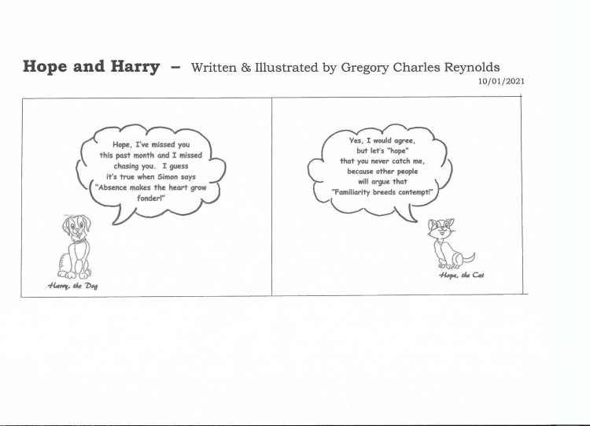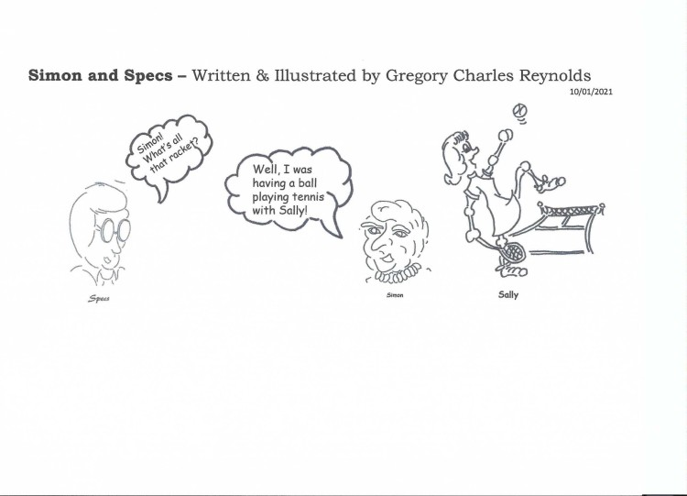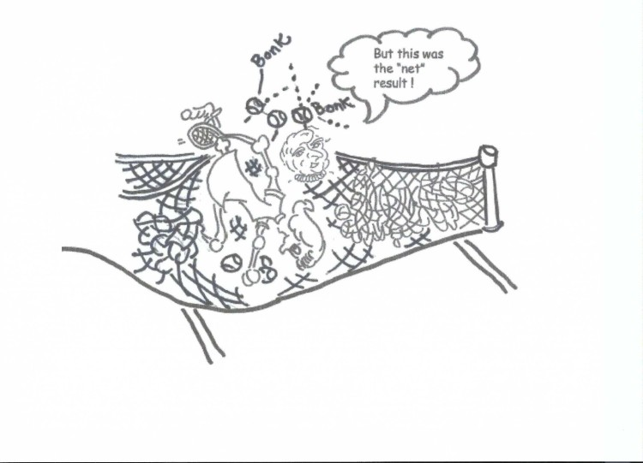
- 4) HOPE MATTERS! SELECTED QUOTES REFERENCING HOPE AND RESILIENCE
- “Hope, like the gleaming taper's light,
Adorns and cheers our way;
And still, as darker grows the night,
Emits a brighter ray.”
  - Oliver Goldsmith, The Captivity, Act II, scene 1 (as quoted in Wikiquotes)
- “Hope is a good thing, maybe the best of things, and no good thing ever dies.”
- Andy Dufresne in The Shawshank Redemption, film directed by Frank Drabont, produced by Castle Rock Entertainment and distributed by Columbia Pictures, 1994.
- “Fear can hold you prisoner…Hope can set you free.”
- Quote from the theatrical release poster for The Shawshank Redemption.
On Hope and Humor – (One of the many components of Resilience):
- “Without laughter, life on our planet would be intolerable.”
- Allen, Steve, (1981). Funny People (1981).
- “Humor, to me, is a crucial part of life in general. It’s such an incredibly subtle and passionate way of relating to people. Your sense of humor communicates what you are, your approach to life…. Also, you do it (I do it), when you’re under pressure, it’s a way of dealing with impossible situations. Untenable situations can only be dealt with through humor, if not despair and resignation. So, I prefer the humor. ”
- David Cronenberg, from an Interview with Bette Gordon, Bomb Magazine, January 1,1989.
- “To me, there are three things we all should do every day. We should do this every day of our lives. Number one is laugh. You should laugh every day. Number two is think. You should spend some time in thought. Number three …you should have your emotions moved to tears, could be happiness or joy. But think about it. If you laugh, you think, you cry, that’s a full day.”
- Jim Valvano – March 4, 1993 – From his acceptance speech at the annual ESPY Awards honoring him with the Arthur Ashe Courage and Humanitarian Award.
Punchlines - September, 2021
I’ve decided to update this web page by separating it into 3 segments:
- Featured “Punster” of the Month – This section includes a few puns from various authors and writers. Each month, a punster will be featured in this section. This month’s selections come from Gary Blake – author of Does the Name Pavlov Ring a Bell? – 879 Hilarious Puns to Test Your Wit.
- “Hope’s” Captivating Cartoon Characters - Hope and Harry and Simon and Specs – These are Cartoon characters I have enjoyed creating in the past and resurrected for this website. As a frustrated artist during my undergraduate college years, I switched to trying my hand at cartooning and created a couple of characters. This month, Hope, the cat, and Harry, the dog will be joining Simon and Specs as they address some of the common idioms, terms, proverbs, cliches, expressions, sayings, and abbreviations in the English language … interjecting a few puns along the way.
- Hope Matters! Selected quotes referencing Hope and Resilience. This section will feature selected quotes from various sources referencing Hope and Resilience throughout the ages.

1) Featured "Punster" of the Month - Gary Blake
Author of Does the Name Pavlov Ring a Bell? – 879 Hilarious Puns to Test Your Wit (2018). Skyhorse, Kindle edition.
Winston Churchill received the following telegram from George Bernard Shaw: “Here are two tickets to my play. Bring a friend—if you have one.” Churchill wired back to Shaw: “Cannot come to the opening night. But will be happy to attend the second night—if you have one.” This was a Churchillian example of a barbed wire.
Blake, Gary. Does the Name Pavlov Ring a Bell?: 879 Hilarious Puns to Test Your Wit (p. 46). Skyhorse. Kindle Edition.
Charles Dickens was despondent in a Paris bar, telling the bartender, “It is the worst of times, for I am without an idea for a new work. Let me partake of a vodka martini,” to which the bartender responded, “Olive or twist?”
Blake, Gary. Does the Name Pavlov Ring a Bell?: 879 Hilarious Puns to Test Your Wit (p. 50). Skyhorse. Kindle Edition.
A filibuster is a Capitol offense.
Blake, Gary. Does the Name Pavlov Ring a Bell?: 879 Hilarious Puns to Test Your Wit (p. 40). Skyhorse. Kindle Edition.
And my absolute favorite….
Seven days without a pun makes one weak.
Blake, Gary. Does the Name Pavlov Ring a Bell?: 879 Hilarious Puns to Test Your Wit (p. 16). Skyhorse. Kindle Edition.

2) "Hope's" Captivating Cartoon Characters
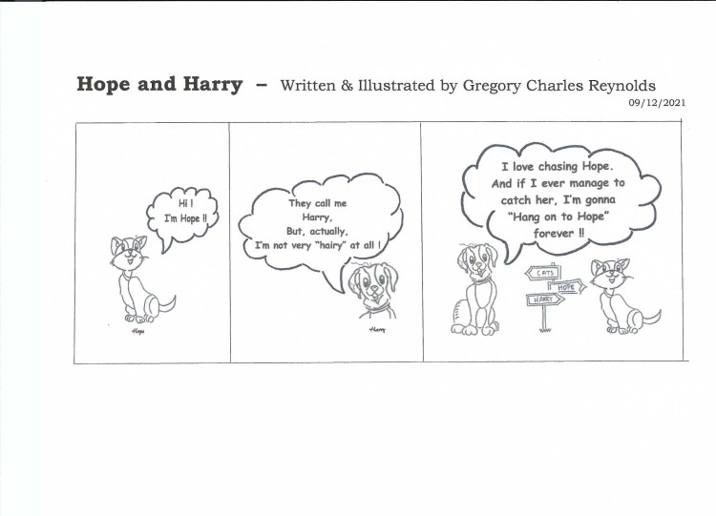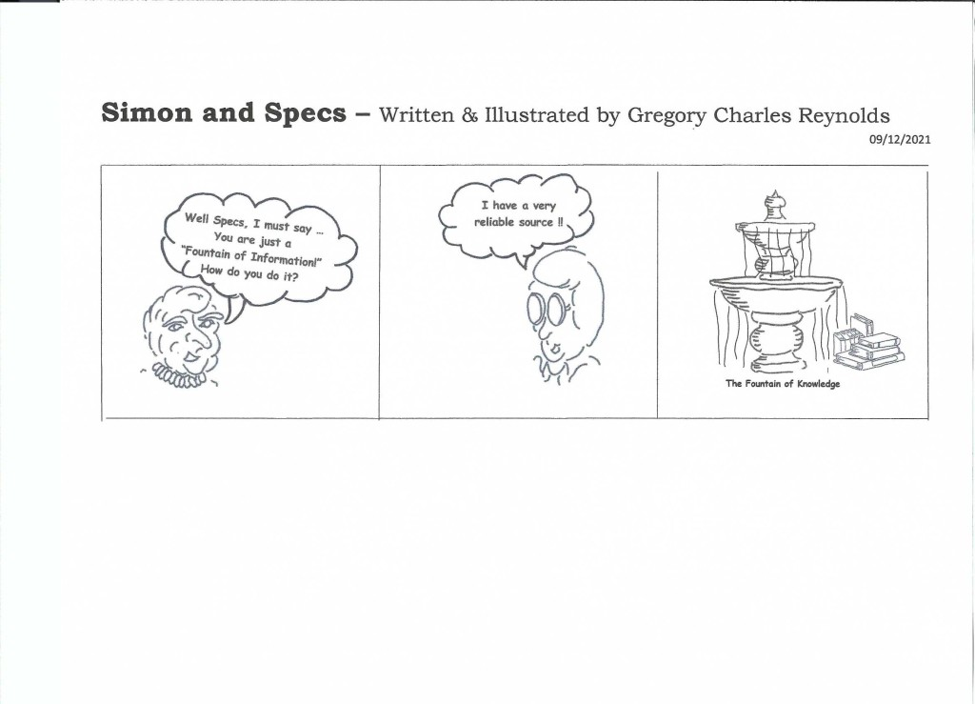
3) HOPE MATTERS! Selected quotes referencing Hope and Resilience
- “Nature has fixed no limits on our hopes.” - Bjork, “Hope” on Volta (2007) quoted in Wikiquote https://en.wikiquote.org/w/index.php?title=Hope&oldid=2998066
- “Optimism is the faith that leads to achievement; nothing can be done without hope.” -Helen Keller, Optimism (1903).
- “There are three lessons I would write, Three words — as with a burning pen, In tracings of eternal light Upon the hearts of men.
Have Hope. Though clouds environ now,
And gladness hides her face in scorn,
Put thou the shadow from thy brow, —
No night but hath its morn.
Have Faith. Where'er thy bark is driven, —
The calm's disport, the tempest's mirth, —
Know this: God rules the hosts of heaven,
The habitants of earth.
Have Love. Not love alone for one,
But men, as man, thy brothers call;
And scatter, like the circling sun,
Thy charities on all.
Thus grave these lessons on thy soul, —
Hope, Faith, and Love, — and thou shalt find
Strength when life's surges rudest roll,
Light when thou else wert blind.”
- Friedrich Schiller, Hope, Faith, and Love (c. 1786); also known as "The Words of Strength", as translated in The Common School Journal Vol. IX (1847) edited by Horace Mann, p. 386

