The Many Faces and Voices of Hope

As I mentioned in September’s blog posting:
“In future blog postings, I will be including a section entitled “The Many Faces and Voices of Hope”. In this section, I intend to capture the thoughts, words, feelings, and emotions of individuals and their acquaintances who have acknowledged hope. . . in whatever form that may take.” Greg Thomas from Minnesota was such an individual. I am privileged to provide our blog readers with this information about him and the contributions he made to the Hope Heritage. After reviewing the following, I would encourage you to identify other individuals (both well known and semi-well known) for inclusion in future blog postings. Thanks!

The Many Faces and Voices of Hope
Greg Thomas (1952 - 2017)
Montgomery, Minnesota
A story of a building restored, and a life renewed.

Cancer confirmed – It’s a diagnosis, no one wants to receive. But in May, 2009, the doctors confirmed that Greg Thomas, who had been dealing with headaches, earaches, and pain in his jaw, had stage 4 head and neck cancer. The cancer was considered inoperable.
Medical Treatment Begun and ended. The doctors attempted to treat the illness with 3 rounds of Chemotherapy and radiation and removed all of Greg’s teeth. Since swallowing was a problem, Greg had to use a feeding tube to eat. His weight dropped from 200 pounds to 145 and physically he felt wiped out. At that point, the doctors stopped the treatment and decided to wait and see if the treatments had any effect in controlling the disease. The doctors could not say how long Greg had to live.
Questions. Understandably, Greg had several questions for himself…”What was going to happen to me?” How would I take care of myself if I got worse? Did I put myself through all this torture for nothing?”
A walk, a prayer, and a clear answer received. Seven years prior to receiving his cancer diagnosis, Greg had moved to rural Montgomery, Minnesota. His previous work experience had resulted in a number of different jobs including plumbing, roofing, insulation, etc. Following his move, he had built a workshop on his property and started his own furniture restoration business.
When his illness hit with a vengeance, Greg found it difficult to work, but he enjoyed taking walks with his dog Maggie. Many of the walks led him past an old, dilapidated church which had not been in use for years and was badly in need of repair. Greg would often sit on the front steps of the church to recover his strength, reflect on his condition, and pray. One such occasion while he was sitting, he closed his eyes and told himself that he wasn’t ready to give up living. So he prayed this prayer: “Lord, before I leave this earth I want to do something for you.”
Then Greg opened his eyes, looked at Maggie sitting next to him, and said, “Come on, girl, time to go home.”
At that moment, a remarkable thing happened. As Greg relates, “Maggie didn’t race ahead of me as usual. I turned to see what she was up to. She stood still at the top of the steps, her head lifted, as if she was listening for something.
I was the one who heard it though. A thought so clear that it had to come from the Lord.
“Restore the church.”
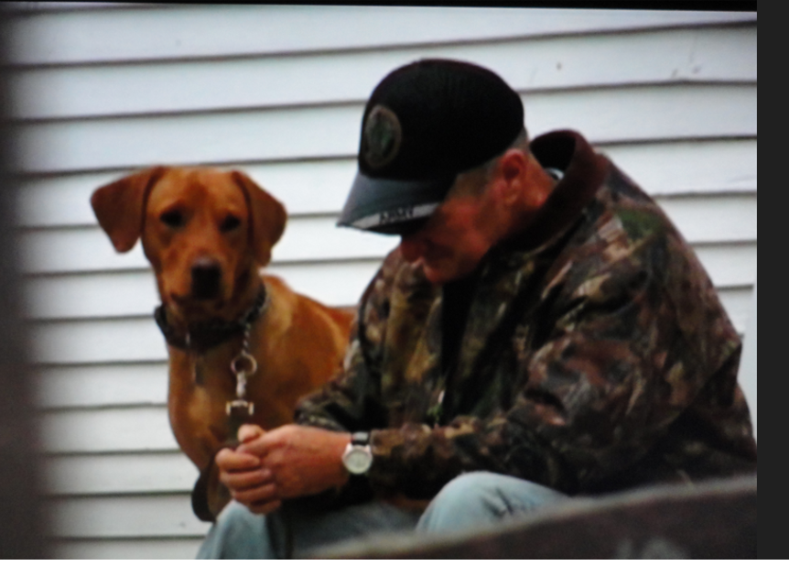

Greg’s response and actions taken. Greg wondered why God was directing him, of all people, to do that. “The church was in terrible condition. FGixing it up would take years. Time I definitely didn’t have.”
What follows in this story is incredible. Greg used his skills to start restoring and complete rebuilding the church. It was far from easy. In Greg’s own words…”I got to know that little church inside and out, from it’s leaky roof right down to its sagging floor. My to-do list grew. Retile the roof. Replace the floorboards. Repaint the interior. Remove the rust from the bell. Bring the pews home to refinish. I just took it one day at a time and stopped worrying about whether I would complete each project on my list.” 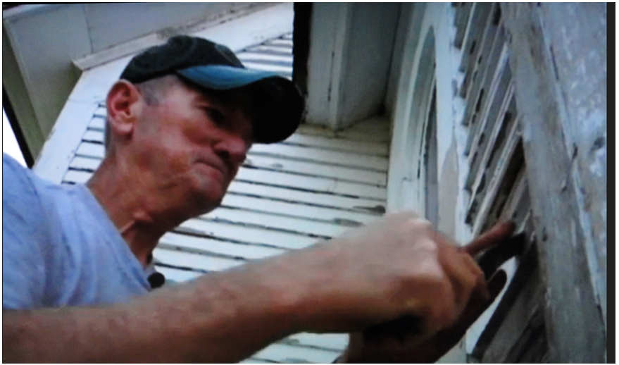
As Greg continued to work, days turned into weeks, weeks turned into months, and months turned into years. Greg’s sister Brenda continued to worry. “Are you taking care of yourself?” She asked. “Shouldn’t you be resting? Your health needs to be your first priority.” But Greg responded with the following: “The more I worked, the better I felt. Every morning I woke up energized, eager to get to the church.”
An updated diagnosis. Four years and 23 days after Greg’s 2009 diagnosis, Greg’s doctors removed his feeding tubes (the ones they said he would need for the rest of his life). He started to eat solid food and was officially considered in cancer remission.

An end to the story? A building restored and a body and soul renewed.
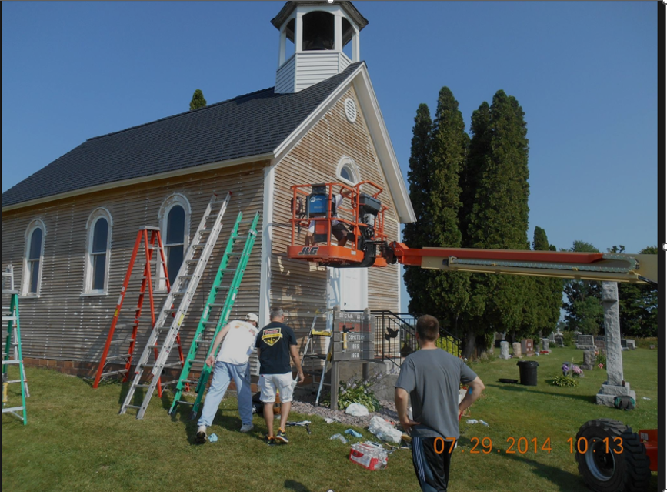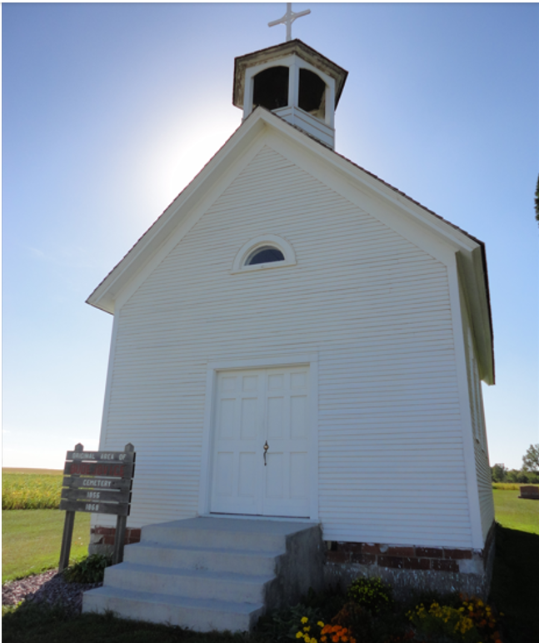

Greg’s amazing story was captured in a number of articles including:
- Guidepost Magazine (May, 2015). “Anew: Living with Cancer.” pp 58-62.
- Reader’s Digest. (April, 2015). “Miracles That Stunned Doctors: The church that cured cancer.” Harlan, Iowa. Vol 185: Issue 1109. Page 98.
- Lonsdale Area News – Review (Saturday, July 14, 2012). Pavek, Jacqueline A. “Making Memories: Thanks to local man’s efforts, historic church sees new life.” Lonsdale, MN. pages 1-2A.
- Greg was also featured in a number of segments on Kare 11 News in Minnesota

Life Lessons. Greg passed away on July 11, 2017. Unfortunately, cancer had returned after being in remission. However, his death does not diminish the fact that hope and action both played a significant role in prolonging the life of this remarkable individual. A building was restored and a body, soul, and a reason and purpose for living for this individual was renewed.
Greg Thomas is a shining example of the approach we should all take to the problems, disappointments and adversity we face in life.
I believe that Greg was the embodiment of the words we quoted above and that he lived them until the day he died:
“Here is a test
to find out if your mission in life
is complete.
If you’re alive, it isn’t.”

An extremely gifted and talented individual . . .We can learn much from Greg Thomas and his courageous approach to life. His legacy will live on and on among those who knew him and loved him and those who have read about him. I, for one, intend to keep that legacy alive!

