Keys to Resilience
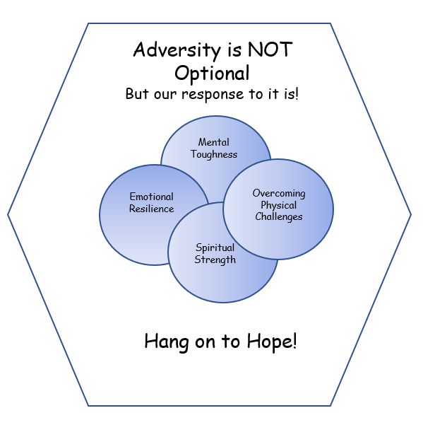

Spiritual
Strength

“Everyone is on a spiritual path; most people just don’t know it.”
Marianne Williamson (1993). A Return to Love: Reflections on the
Principles of A Course in Miracles.
Haper Collins, Harper One Edition (2012). New York, NY. pp. 40-41.

The re-emergence of spirituality in our culture is real. Perhaps it never disappeared completely, but the emergence of some particularly arrogant and very vocal atheists in the first and second decades of the 21st century galvanized many of us to re-examine our beliefs and actions regarding our faith in a Supreme being.
The strength we can obtain from addressing and embracing the spiritual part of our consciousness and our total being is one of the keys we all can utilize and share as an essential “key” to resilience in dealing with adversity.
Spirituality has many, many aspects and in this section I have included some of the foremost guides and resources to assist us on our journey through our lives. The strength that we can receive through connecting with our own spirituality is probably the greatest “key” to a productive and joyful life!
This webpage, along with all of the other webpages on the “adversityisnotoptional.com” website, will continue to be updated as we all grow together in our understanding of how to interact in our relationships with each other and in our journeys through this world and into the world beyond.

SPIRITUAL LAWS
In addition to physical laws governing the universe, many philosophers, theologians, and religious thinkers throughout the ages have postulated the existence of a spiritual realm which they believe is also governed by laws. We can identify some of these spiritual laws by following the links below:
7 Spiritual Laws In The Bible - Bible Wisdom Hub
12 Universal Laws & How To Use Them To Unlock A More Spiritual Life
33 Spiritual Laws of The Universe
Many other authors, both religious and secular, have identified spiritual laws. You may want to check out the following book by Deepak Chopra:
Chopra, Deepak, (1994). The Seven Spiritual Laws of Success. A practical guide to the fulfillment of your dreams. Amber-Allen Pub. San Rafael, CA.
Chopra, Deepak, (1997). The Seven Spiritual Laws for Parents. Guiding your children to success and fulfillment. Harmony Books. New York, NY.

SPIRITUAL POWERS
“Spiritual power is often described as the inner strength that allows individuals to face life’s challenges with grace and wisdom. It is cultivated through practices such as meditation, prayer, and mindfulness, leading to increased emotional intelligence and self-awareness.”
Jennifer McVey and Aly; Ruciano. What is Spiritual Power?
https://www.wikihow.com/spiritualpower

In addition to spiritual laws, spiritual powers have been identified in the spiritual realm. These powers originating in, and disseminated from, the spiritual realm generally include beliefs, attributes and emotions such faith, strength, love, imagination, will, understanding, order, judgement/wisdom and so forth. In the late 19th and early 20th centuries, Charles and Myrtle Fillmore explored metaphysical methods of healing and ancient wisdom to arrive at new interpretations of what it means to be human and alive. The twelve spiritual “powers” which they identified along with their other teachings led to the eventual founding of the Unity church and organization. For more information regarding the history and principles of the Unity organization you may wish to visit their website at Unity.org. An understanding to the twelve powers identified by the Fillmores are highlighted in a number of books and publications including:
Hausman, Winifred Wilkinson, (1978, 1999). Your God-Given Potential: Unfolding the twelve spiritual powers. Unity Books Publishers, Unity Village, MO.
Hasselback, Paul and Cher Holton, (2010). Power Up: The twelve powers revisited as accelerated abilities. Prosperity Publishing House, Durham, NC.
Additionally, you may want to follow the discussion of spiritual powers on the website below.

What Are The 12 Spiritual Powers And How They Can Transform Your Life [Answered!]

SPIRITUAL GIFTS and SPIRITUAL GROWTH
Our growth as individuals often comes as we acknowledge and utilize the gifts we have at our disposal and the obstacles and adversity we have overcome. Many religions have identified spiritual gifts we have been given or can acquire.
Christian authors and guides offer a number of these gifts as can be seen in the following internet link:
What Are Spiritual Gifts? Definitions, Types, and Examples | Christianity.com
However, our spiritual gifts and our spiritual growth are not limited to one specific religious teaching, but to a whole array of spiritual counselors and guides. The following list and accompanying resources are an excellent introduction to gifts and growth that we can discover:

The Gift of Change
Our ability to change our beliefs, thinking, and actions is certainly one of the greatest gifts available to us. Oftentimes this takes considerable time, but the decision to change can be made in a moment and the accompany change in it
- Williamson, Marianne, (2004). The Gift of Change: Spiritual guidance for a radically new life. Harper Collins Publishers. New York, NY.

- Eger, Edith, (2020). The Gift: A survivor’s journey to freedom. Penguin Random House UK (2020). Simon & Schuster (2021). New York, NY.

- Holmes, Ernest, (1982, 1999 2nd Ed.). How to Change Your Life. Science of Mind Publishing. Deerfield Beach, FL.

- Cameron, Julia, (1999). Transitions: Prayers and declarations for a changing life. Jeremy P. Tarcher/Penguin Putnam. New York, NY.

- Neeld, Elizabeth Harper, PhD. (2005). Tough Transitions: Navigating your way through difficult times. Time Warner Book Group. New York, NY.

The Gift of Choice
Our ability to choose a different belief, a different thought, a different path or a different action has been referred to as our greatest power. In his introduction to the revised edition of the inspirational classic: Your Greatest Power by Martin Kohe, Don M. Green, an executive director of The Napoleon Hill Foundation, describes “choice” as a “right” which is available to all of us.
- Kehe, Martin, (1953, 2004). Your Greatest Power. The Napoleon Hill Foundation. Wise, Virginia.

- Eger, Dr. Edith Eva, (2017). The Choice: Embrace the possible. Simon & Schuster, New York, NY.

- Keiper, William (2013). The Power of Urgency. First Global Partners LLC. Scottsdale, AZ. Please Note: Although the author does not specifically address spirituality in this book, he does address the proactive choices we should make in living and transforming our lives and the lives of those around us. Keiper presents the reader with 17 “Urgency Rules” we need to embrace … including Proactive Urgency, Urgency by Choice, Choosing to Act with on-demand urgency, Purposeful Urgency, and Neutralizing Fear. The author has also written “LIFE Expectancy, It’s Never Too late to Change Your Game”…a book which could be included above in the “Gifts of Change”.

The Gift of Fear
Most people do not think of fear as a gift, but rather as a negative feeling or emotion. But there are important uses for feelings of fear. It is often present when we are facing dangerous physical situations or situations where we feel inadequate to respond. It is important to acknowledge the fear, but then determine to take action in spite of feeling fear. Doing so can often lead to a successful outcome in a situation. Two resources that address the gift of fear which you may want to consult include the following:
- De Becker, Gavin (1997). The Gift of Fear: And other survival signals that protect us from violence. Dell Pubishing/Random House, New York, NY. De Becker has also written Protecting the Gift and Fear Less.

- Jeffers, Susan (2006). Feel The Fear … And Do It Anyway: Dynamic techniques for turning fear, indecision, and anger into power, action, and love. Ballantine Books. New York, NY.

The Gift of Faith
“Faith is the most powerful force in the world….People who have strong faith are fearless; they can overcome anything. There is no obstacle or adversity that they cannot surmount. In the very depths of their lives, no matter what happens, they lead lives of ‘the greatest of all joys.’
Ikeda, Daisaku, (1999), Faith into Action: Thoughts on Selected Topics.
World Tribune Press. Santa Monica, CA. page 110.
(Nichiren Daishonin Buddhism)

Faith is not something that is only the province of the religions of the world. Faith is available to all people everywhere regardless of their religious affiliation. Whether or not a person chooses to acknowledge it in their lives, faith can become a cornerstone to a life well-lived. The September 2025 blog posting, “Hope and Faith”, dealt in considerable detail regarding the importance of faith as explained by numerous authors. Here is some of the wisdom taken from various sources:
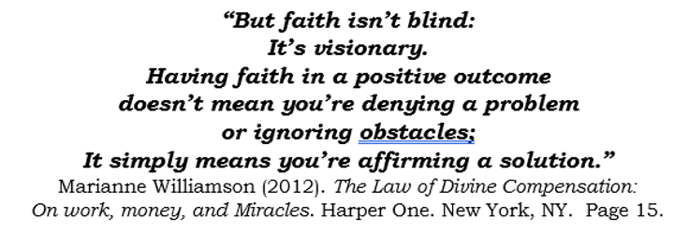
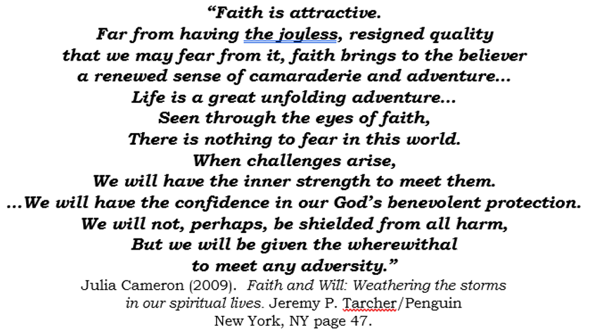

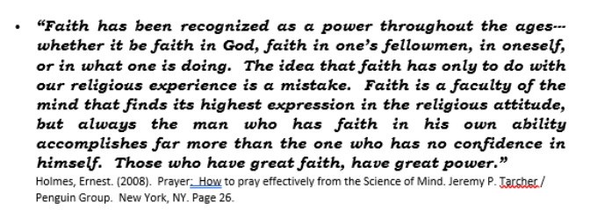

The Gift of Free Will
“If you do not choose to deal with the personal issues
that keep you from expressing yourself at your highest,
then you are choosing to block your own way.
God Himself will bow before that choice,
Because the gift of Free Will was given to you at creation.
Yet He will move heaven and earth to help you choose again.
He will find a way
To offer you the chance to live a different life.”
Williamson, Marianne, (2004). The Gift of Change: Spiritual guidance for a radically new life. Harper Collins Publishers. New York, NY.
“Free will is generally understood as the capacity or ability of people to:
(a) choose between different possible courses of action,
(b) exercise control over their actions in a way that is necessary for ultimate source or originator of their actions, or
(c) be the ultimate source or originator of their actions.
Free will is closely linked the concepts of moral responsibility and moral desert, praise, culpability, and other judgements that can logically apply only to actions that are freely chosen. It is also connected with the concepts of advice, persuasion, deliberation, and prohibition.”
Wikipedia -
Free will - Wikipedia
In a Christian context, it is believed that individuals have free will to choose their own thoughts and actions even if this is contrary to what God may intend for the individual. If an individual chooses to act against the God’s will, forgiveness for his or her actions is available by God’s grace provided the individual is sincere in their repentance.
“Christ and the spiritual hierarchy
never – no matter how great the need
or important the incentive –
infringe the divine right of men to take their own decisions,
to exert their own free will,
and to achieve freedom by fighting for freedom -
individually, nationally, and internationally.”
Bailey, Alice (1947). The Reappearance of Christ. Page164.

“What we really mean by free will... is the visualizing of alternatives and making a choice between them. ...the central problem of human consciousness depends on this ability to imagine.”
Bronowski, Jacob (1978) Origins of Knowledge and Imagination.
Yale University Press. New Haven, Connecticut.
SPIRITUAL SURRENDER
The act of surrendering has many negative connotations. In most cases, we consider surrendering as an act of as “giving up.” This is most often the case in war among people and countries or in hard-fought athletic contests or other events. But in a spiritual sense, surrendering can be thought of as “giving in” to a power greater than ourselves to bring about a successful solution to a problem, relationship, or issue.
As noted above, several religious and secular authors have written articles and books regarding spiritual topics. The following authors have devoted whole chapters in their books to the subject.
- Connors, Sharon, (2004). Adventures in Prayer: Praying your way to a God you can trust. Bantam Books/Random House. New York, NY. Chapter 9 – Surrender and Willingness: Prayers that Open Heaven’s Door

- Williamson, Marianne, (2012). The Law of Divine Compensation: On money, work, and miracles. Harper One, Harper Collins. New York, NY. Chapter 8.

SPIRITUAL DISCIPLINES / SPIRITUAL PRACTICES
One of the most defining and informative works on the subject of spiritual disciplines and spiritual practices was written by John Mark Comer. Recently I had the privilege of participating in a 8-week group discussion of videos, readings, and exercises from the Companion Guide to Comer‘s book, “The Practicing the Way Course: An eight-session primer on spiritual formation”. This 8-week primer on Spiritual Formation encompassed the following disciplines / practices:
Prayer
Sacred Texts – Scripture
Rest – Sabbath
Fasting
Solitude
Generosity
Community
Service
Witness
A great deal has been written about Spiritual Disciplines and Practices throughout history. Additional resources to consider include:
- Foster, Richard J. (2018). Celebration of Discipline, Special Anniversary Edition: The Path to Spiritual Growth. Harper One / Harper Collins. New York, NY.

- Thich Nhat Hahn (1998, 2015 ed). The Heart of the Buddha's Teaching: Transforming Suffering into Peace, Joy, and Liberation. Harmony Books / Penguin Random House. New York, NY.

- The Course — Practicing the Way

- Series: Practicing The Way — Bridgetown Church

SPIRITUAL DNA – THE SOUL
Each of us have within us what some people have called “Spiritual DNA”. Others may refer to this as the “Soul”.

“Sail forth --- steer for the deep waters only,
Reekless O soul, exploring, I with thee,
and thou with me,
For we are bound where mariner has not yet
dared to go,
And we will risk the ship, ourselves and all,
O my brave soul!
O farther farther sail!
O daring joy, but safe! Are they not all the
seas of God?
O farther, farther, farther sail!”
Walt Whitman, Leaves of Grass (1891-92): Passage to India.
Whitman, Walt, (1982). Complete Poetry and Prose of Walt Whitman.
Literary Classics to the United States. New York, NY pp. 539-540.

Throughout the ages, from ancient times until today, the subject of the soul has intrigued and perplexed mankind. Endless discussion and debate has circulated around the souls existence and whether or not it is a part of an individual’s psyche or makeup during his or her lifetime on earth and whether or not it continues to survive in some form or other after a person’s death.
Likewise, there has been no agreement on the soul’s purpose and function. We often hear the phrase “The Dark Night of the Soul”, but what does that really mean for individuals?
The Soul defined:
Websters online Dictionary defines the soul as
-”The spiritual principle embodied in human beings, all rational and spiritual beings, or the universe.
- A person's total self
- Spiritual or moral force”

Soul - Wikipedia

“The soul is the purported immaterial aspect or essence of a living being. It is typically believed to be immortal and to exist apart from the material world.”
Please note: I am indebted to the editors of the on-line encyclopedia Wikipedia for the following information regarding the Soul. As noted in their “Policies and Content” section, “Wikipedia is free content that anyone can use, edit, and distribute”. The encyclopedia was launched in 2001 and initially experienced content reliability issues. More recently, editing restrictions and content reviews by the editors have vastly improved the reliability of article content. But as with all media related content, I would approach the subject matter presented with caution and constantly question anything that appears contradictory or questionable.

The Soul’s purpose and function
“The soul has been the central area of interest in philosophy since ancient times. Socrates envisioned the soul to possess a rational faculty, its practice being man's most godlike activity. Plato believed the soul to be the person's real self, an immaterial and immortal dweller of our lives that continues and thinks even after death. Aristotle sketched out the soul as the "first actuality" of a naturally organized body—form and matter arrangement allowing natural beings to aspire to full actualization.”
Soul - Wikipedia
“Different religions conceptualize souls in different ways. Buddhism generally teaches the non-existence of a permanent self (anattā), contrasting with Christianity's belief in an eternal soul that experiences death as a transition to God's presence in heaven. Hinduism views the Ātman ('self', 'essence') as identical to Brahman in some traditions, while Islam uses two terms—rūḥ and nafs—to distinguish between the divine spirit and a personal disposition. Jainism considers the soul (jīva) to be an eternal but changing form until liberation, while Judaism employs multiple terms such as nefesh and neshamah to refer to the soul. Sikhism regards the soul as part of God (Waheguru), Shamanism often embraces soul dualism with "body souls" and "free souls", while Taoism recognizes dual soul types (hun and po).”

The Dark Night of the Soul
Dark Night of the Soul - Wikipedia
” The term "dark night of the soul" can be used as a synonym for a crisis of faith. More generally, it is "used informally to describe an extremely difficult and painful period in one's life".”
Inayat Khan states, "There can be no rebirth without a dark night of the soul, a total annihilation of all that you believed in and thought that you were."
Khan, Hazrat Inayat. Thinking Like The Universe: The Sufi Path Of Awakening.

Joseph Campbell states "The dark night of the soul comes just before revelation. When everything is lost, and all seems darkness, then comes the new life and all that is needed."
Campbell, Joseph. Reflections on the Art of Living: A Joseph Campbell Companion

Ronald W. Pies: “The phrase "dark night of the soul" is often used informally to describe an extremely difficult and painful period in one's life, for example, after the death of a loved one; the break-up of a marriage; or the diagnosis of a life-threatening illness. For many, the loneliness, isolation and fear associated with the COVID-19 pandemic is, indeed, a dark night of the soul. There is nothing wrong with these informal usages, and they have obvious links to the concepts of demoralization and despair, as we have defined them. But they differ significantly from the original meaning and context of the phrase, as first conceived by the Spanish mystic John of the Cross (1541–1597 AD).
Ronald W. Pies (2020), Psychiatry and the Dark Night of the Soul

Roberto Assagioli states:
Before the full and final victory, however, the soul has to undergo another test: it must pass through the "dark night" which is a new and deeper experience of annihilation, or a crucible in which all the human elements that go to make it up are melted together. But the darkest nights are followed by the most radiant dawns and the soul, perfect at last, enters into complete, constant and inseparable communion with the Spirit, so that – to use the bold statement employed by St John of the Cross – "it seems to be God himself and has the same characteristics as him"
Assagioli, Roberto (2007). Transpersonal Development. Inner Way Productions. pp. 146–147

In modern times, it would appear that “the dark night of the soul” should be viewed in at least two parts or stages: The first part consisting of a period of confusion, helplessness, and darkness followed by the second part consisting of movement toward illumination and light.
Additional resources you may want to consider regarding the dark night of the soul and the soul itself would include:
- May, Gerald G. (2004). The Dark Night of the Soul. A Psychiatrist Explores the Connection Between Darkness and Spiritual Growth. New York City: HarperCollins. ISBN 0-060-55423-1.

- McKee, Kaye P. (2006). When God Walks Away. A Companion to the Dark Night of the Soul. New York City: Crossroad Publishing Company. ISBN 0-824-52380-6.

- Work info: Dark Night of the Soul - Christian Classics Ethereal Library

- Gnostic.Org Mysticism: The Nature and Development of Spiritual Consciousness by Evelyn Underhill

- Summary of The Dark Night of the Soul by St. John of the Cross – Prodigal Catholic

- Beckwith, Michael B. (2008). Spiritual Liberation: Fulfilling your soul’s potential. Atria Books/Simon & Schuster. New York, NY.

- Gautiere, Bill and Kristi, (2021). Journey of the Soul: A practical guide to Emotional and Spiritual Growth. Revell Books / Baker Publishing Group.

- Ortberg, John (2014). Soul Keeping: Caring for the most important part of you. Zondervan, Grand Rapids, MI.

